To Request Azure Resource Access:

Go to Home and Type “Azure AD P” in the main search bar:

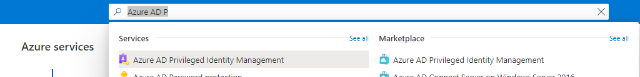

Click on “Azure AD Privileged Identity Management”.

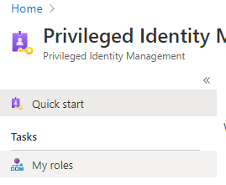

Click on “Azure Resources”.

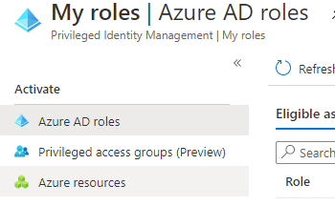

Type “BPC” in the search bar.

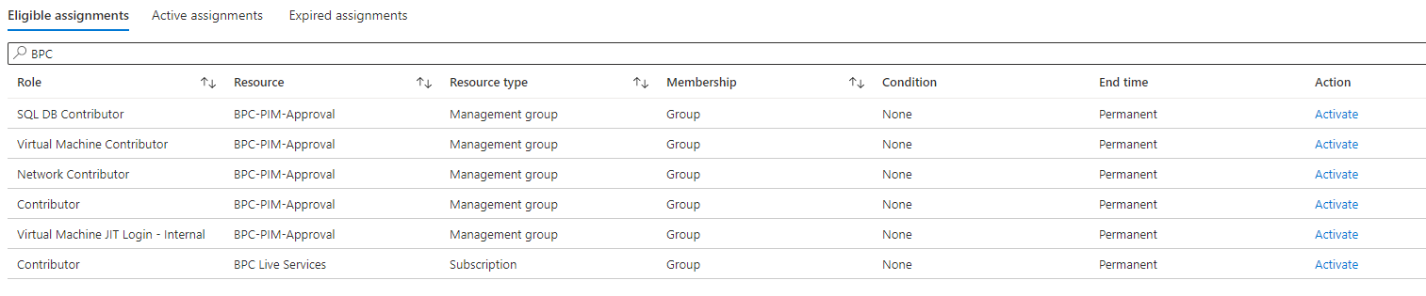

Select the required Role and click “Activate on the far right Action Column.



Type in the reason and ticket information then select Activate.

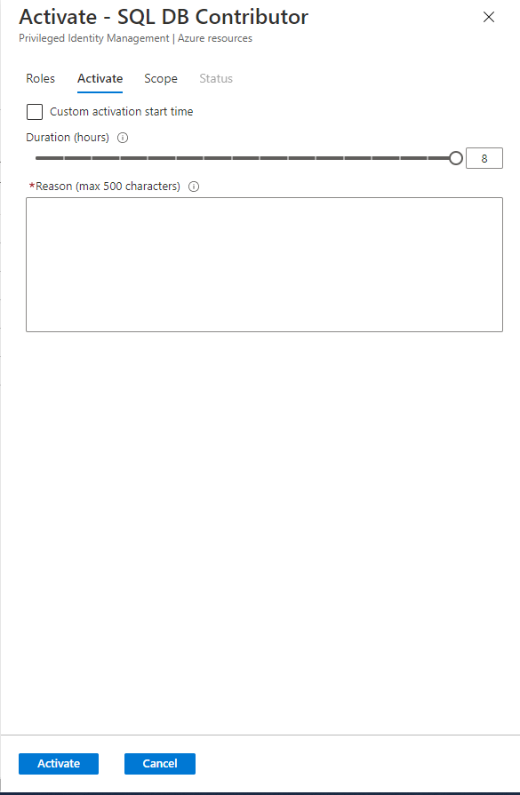

Wait for approval or mention PIM approval required in your Ops group.